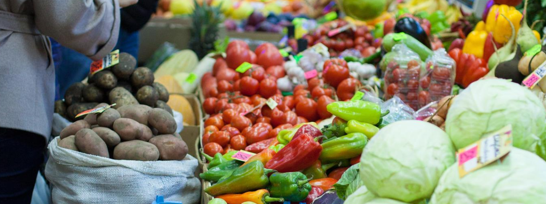

**Food Poverty in Recent Years (2015 - 2022)**



**Data Science Team Project, May 2022**

**Data Accelerator Course, Cohort January - May 2022**

**Mentor:**

**Jayanthi Santhanam**

**Team members:**

**Wafa Eltahir, Marjorie Fisher, Imran Farooqui, Huijun Yan, Eleni Sakkoula**

**Table of Contents:**

**Introduction** **3**

**Purpose of the report** **3**

**Methodology, Challenges and the Extend of the Research Completed** **3**

**Food Poverty and Inflation: an overview** **4**

**Charities Surveyed** **6**

The Clutha Trust 6

The Trussell Trust 7

The Food Foundation 7

IFAN (Independent Food Aid Network) 8

**Governmental Organisations Surveyed** **8**

The UK and Scottish Governments 8

ONS (Office for National Statistics) 8

**Comparative Data Analysis** **8**

Number of parcels distributed by food banks in the UK in 2019 and 2020 9

The impact of Covid-19 Pandemic on Food Security 10

Number of parcels distributed by food banks in Scotland, 2015 to 2022 11

Types of organisations that reported providing free/subsidised food in Scotland 18

Measuring Food Security 19

Food Poverty and Income 21

Food Poverty and Cost of Living 22

**Conclusions** **26**

**Recommendations** **28**

**Acknowledgments** **30**

**References** **30**

# Introduction

The report was completed on the issue of ‘**Food Poverty in recent years**’, a data analytical project of the Data Management course, by its students as part of a team project assignment. The objectives of the assignment were to conduct multi-layered research on issues affecting Food Poverty like inflation, the rising cost of living affecting the living standards, public health, and daily nutrition. The research is primarily locally focused - but not exclusively - on Scotland and specifically in the Glasgow area by examining the work of local charities that are active in the local community like The Clutha Trust and on a UK-wide level The Trussell Trust. The method used in this study can be extended to all of the UK.

# 

# Purpose of the report

The purpose of the report is to compare numbers, findings, and case stories by third sector groups i.e., The Clutha Trust, The Food Foundation, The Trussell Trust in comparison to food and income poverty data in publications and coverage by official governmental bodies like the Scottish and UK governments, the ONS (Office for National Statistics) and so on. In this report various parameters have been taken into consideration in addressing the main question.

**Is the data established by governmental bodies matching the reality and insight claimed by third sector groups and individuals and what are the main parameters relating to the current Food Poverty crisis?**

# 

# Methodology, Challenges and the Extend of the Research Completed

The methodology for this report includes extensive research on the topic in news, publications, communicating with NGO groups, charities, and governmental bodies, contacting interviews where applicable, obtaining open-source data that is available on this issue and performing a data analysis on the findings. The data collection, analysis and visualisation include a range of collaboration, project management and data analysis software tools such as Zoom, SpatialChat, Slack, Python, Microsoft Excel, Google Sheets, G-Suite, Moodle, Miro, Power BI. The analysis is descriptive and involves the application of statistical methods to identify relationships within the datasets that were examined.

The topic of Food Poverty is a vast one and interconnected with various socio-economic issues like inflation, policy-changes, fuel poverty, living standards, public health, and the Covid-19 pandemic. In this respect establishing a tangible hypothesis to assess on a manageable scale - that of primarily focusing on Scotland - along with the effort to find associated data for comparisons, the lack of the very latest relevant data, the limitations that charities face in terms of time availability to participate in data sharing collaborations and interviews due to the high demands they are currently facing proved to be a challenging aspect of the process. These statements have been inspired after the initial stage of examining charities like The Clutha Trust.10

In addition, something that needs to be highlighted for this research is that the research itself and the conclusions were based on estimated figures by the various organisations provided (even as per the Scottish Government sub notes in the actual official statistics publications examined). For instance, the estimated nature of data lies upon the fact that some data only goes up to 2021 and some data recording does not include all possible channels (such as additional food support provided in schools/colleges, unregistered temporary community-based activity, help by friends and family that goes unreported and so on).

Furthermore, the issue of data bias has been one of the challenging aspects. For example, there is a high possibility of different distribution in different areas - maybe in one area there are families in constant poverty whereas in other areas there are families needing support for food needs for the first time. In order to deal with these limitations, we would try to find further supporting data, supplementary information like case stories or any other material or articles covering this phenomenon.

# 

# Food Poverty and Inflation: an overview

“***More people are going hungry, an annual study by the United Nations has found. Tens of millions have joined the ranks of the chronically undernourished over the past five years, and countries around the world continue to struggle with multiple forms of malnutrition. The latest edition of the State of Food Security and Nutrition in the World, published in July 2020, estimates that almost 690 million people went hungry in 2019 – up by 10 million from 2018, and by nearly 60 million in five years. High costs and low affordability also mean billions cannot eat healthily or nutritiously.***”1

WHO (World Health Organisation) excerpt on **The** **State of Food Security and Nutrition in the World** report 2020.

*“****In the last ten years, the frequency and intensity of conflict, climate variability and extremes, and economic slowdowns and downturns have increased significantly. The increased occurrence of these major drivers, now exacerbated by the COVID-19 pandemic, has led to a rise in hunger and has undermined progress in reducing all forms of malnutrition, particularly in low- and middle-income countries.****”**2*

Quote from **The** **State of Food Security and Nutrition in the World** report 2021.

The **State of Food Security and Nutrition in the World** is an annual flagship report cooperatively prepared by [FAO](https://www.fao.org/home/en), [IFAD](https://www.ifad.org/), [UNICEF](https://www.unicef.org/), [WFP](http://www1.wfp.org/) and [WHO](http://www.who.int/) to inform on progress towards ending hunger, food security, improving nutrition universally and to provide an analysis on key challenges in the context of achieving the 2030 Agenda for **SDG2****3**(Sustainable Development Goal 2) towards **Zero Hunger**. The report targets a wide audience, including policymakers, international organisations, academic institutions, and the public.

Further to acknowledging the rise of food poverty on a global level as per the alarming statements by the United Nations and The State of Food Security and Nutrition in the World above we can investigate the examination of this crisis on a UK and Scotland basis.

In terms of overall poverty that Food Poverty is a part of, the Scottish Government Communities Analysis Division states that poverty can be measured in several different ways, each of which can tell us something different about poverty. One of the most common measures is relative (income) poverty which identifies people living in households with an equivalised income below 60% of the UK median household income. It therefore measures whether those in the lowest income households are keeping pace with the growth of incomes in the economy. Additionally, it is important to address persistent poverty. Persistent poverty identifies individuals who live in relative poverty for three or more of the last four years. It therefore identifies people who have been living in poverty for a significant period, which is more damaging than brief periods spent with a low income. The impacts can affect an individual throughout their lifetime.4

As defined by Health Scotland, Food Poverty is commonly defined as 'the inability to acquire or consume an adequate or sufficient quantity of food in socially acceptable ways, or the uncertainty that one will be able to do so'. Food poverty is essentially the inability of individuals and households to secure an adequate and nutritious diet. It can affect those living on low incomes, with limited access to transport and poor cooking skills5.

Although often hidden, food poverty has always been with society to a greater or lesser extent. But when people think of food poverty, they often envisage it as something that happened in the past leading to the assumption that in a modern, civilised and outwardly affluent society it simply does not, or indeed, cannot exist. The effects of the Covid-19 crisis and the subsequent increases in inflation have brought the problem into sharp focus, but these were just the last straws to break the camel’s back. The current problem goes much further back. A quick look at the Trussell Trust’s list6 Press Releases on their website reveals reports going back to 2012 effectively charting the development of the current crisis and have consistently linked it to changes in the benefit and welfare system as well as rising living costs and stagnant wages7.

So, why are we talking about Food Poverty now? Many activists, charities, local communities, and social group representatives have been highlighting the alarming news on Food Poverty and the cost-of-living crisis. As Jack Monroe, a prominent activist at the forefront of the Food Poverty debate has stated "*We are currently facing what the mainstream media have dubbed a ‘cost-of-living crisis*"8.

The significant parallel questions that inevitably arise are about how Food Poverty is measured, by whom and the consistency among the various measurements. In the beginning of 2022 Jack Monroe campaigned and gained publicity by investigating the rise of food prices and bringing to light how it can be more unfair for the poorest in society, with price hikes on supermarket basics ranges not accurately reflected by the Consumer Price Index (CPI). Jack Monroe is a food writer, journalist and a political activist and campaigner, and is well-known for campaigning on issues such as poverty and hunger relief. Most of the campaigns that she has worked on are calling for political change and she campaigns a lot on anti-poverty.

Writing in The Guardian, Monroe said: “*A collection of 700 pre-specified goods that includes a leg of lamb, bedroom furniture, a television and champagne seems a blunt and darkly comical tool for recording the impact of inflated grocery prices in a country where two and a half million citizens were forced by an array of desperate circumstances to use food banks in the last year.*” Inflation recently went up to 5.4 per cent, with Monroe arguing that the CPI ‘grossly underestimates the real cost of inflation’.9

This drawing attention on the type of data sampling practised by the ONS as part of the CPI process is key as it demonstrates weaknesses on the data quality and accuracy front by excluding a more detailed view of the price hikes in the essential ranges products that have apparently risen by an incredibly higher percentage that is not sustainable for a rising number of people who are falling into poverty. An example would be that by stating that the price of a standard supermarket 'meal deal' has not risen in price and stayed at approx. £10 - £15 but not including the three times fold increase of the price on basic, cheapest range packet of pasta, rice or bread or pound-shop products is a gross data inaccuracy. This in effect undermines the high level of data quality required for such national public sector reports. In addition, data bias can be viewed by the fact that more high-end products are included that are related to a middle-income household in a richer geographical area than representing the whole population.

Jack Monroe proposed that the Vimes Boots Index would show how inflation affects poorer families the most and how basic food prices going up will create more problems amongst poorer people. Monroe proposed this index to show how much inflation affects those who have less money, particularly as supermarkets reduce their basic product range offerings and those with less money are forced to pay for more expensive supermarket own-brand product ranges. Monroe argues the consumer price index does not cater for people with lower incomes due to the increasingly narrow range of products included in the basic supermarket offerings. In a lengthy Twitter thread, Monroe illustrated the price increase of basic household goods such as pasta: “*This time last year, the cheapest pasta in my local supermarket (one of the Big Four), was 29p for 500g. Today it’s 70p. That’s a 141 per cent price increase as it hits the poorest and most vulnerable households.*” An interesting term “Shrinkflaction” has been created to describe the process of keeping the food price the same, but quantity is actually less.9

# 

# Charities Surveyed

## Icon Description automatically generated with low confidence The Clutha Trust

The Clutha Trust is an OSCR (Office of the Scottish Charity Regulator) registered charity based in Glasgow that provides services and support for the arts (through groups like CAST, a Clutha Actors Studio Trust – The drama group of the Clutha Trust charity), youth groups, and Food Poverty solutions. As Alan Crossan, the Founder of Clutha Trust advocated in his interview to our group “*We are a music/arts charity based in Glasgow, Scotland. At the Clutha Trust we like to give people who donate something for their money. That is why we run concerts – hold events in Pubs & Clubs – basically we entertain people to raise funds*”, “*We are doing around 150 families per week. This has increased slightly over the last few months. Demand is expected to increase again*”. The purpose of the charity is the advancement of the arts, heritage, culture or science, the relief of those in need by reason of age, ill health, disability, financial hardship, or other disadvantages. The Trust's principal objective as defined in the Deed of Trust is to raise and administer funds for the advancement of the arts, heritage, or science, and to provide relief to those in need by reason of age, ill health, disability, financial hardship, or other disadvantages. Donations are made at the sole discretion of Trustees as they see fit. A lot of the communication is with the public and beneficiaries is through the charity’s media channels and is testament to the significant direct action in philanthropy.10

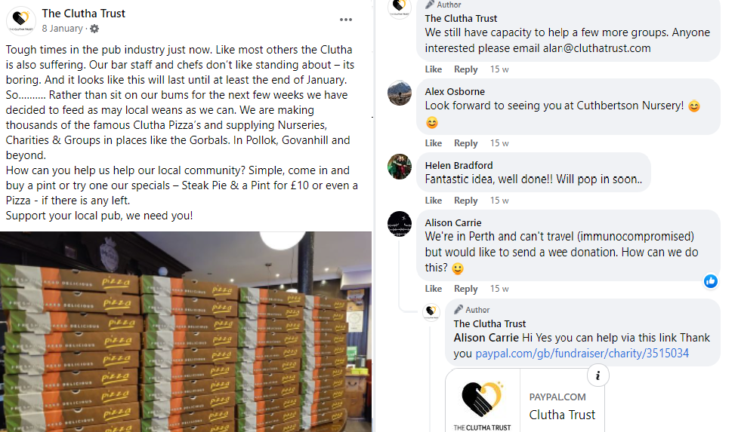

*Image: The Clutha Trust* [*Social Media Page*](https://www.facebook.com/Cluthatrust)*.*

## The Trussell Trust

The Trussell Trust was founded in Bulgaria in 1997 based on a legacy left by Carol’s mother, Betty Trussell. Paddy Henderson started the UK Salisbury Foodbank in his garden shed and garage, providing three days’ emergency food to local people in crisis. The food bank model spread rapidly through church networks. The Trussell Trust supports a nationwide network of food banks and together they provide emergency food and support to people locked in poverty, and campaign for change to end the need for food banks in the UK. They support more than 1,200 food bank centres in the UK to provide a minimum of three days’ nutritionally balanced emergency food to people who have been referred in crisis, as well as support to help people resolve the crises they face. Between April 2019 and March 2020, food banks in their network provided a record 1.9 million food supplies to people in crisis, an 18% increase on the previous year and during the coronavirus pandemic food banks have seen need rise even further.11

## The Food Foundation

The Food foundation was founded in 2014 by Laura Sandy as an independent policy think tank to challenge the current food system and how it was impacting public health. The charity now is registered working in partnership with researchers, campaigners, community bodies, industry, Government, and citizens to galvanise the UK’s diverse agents of change. The charity's vision is a sustainable food system which delivers health and wellbeing for all. It uses surprising and inventive ideas to catalyse and deliver a fundamental change in the food system by building and synthesising strong evidence, shaping powerful coalitions, harnessing citizens’ voices, and driving progress with impactful communications. The charity continually identifies new opportunities for action, and trials new levers for change. Its mission is to change food policy and business practice to ensure everyone, across the UK nations, can afford and access a healthy and sustainable diet. The main areas of focus of the charity are to improve children’s diets, increase vegetable consumption, influence food policy, and influence food policy.12

## IFAN (Independent Food Aid Network)

IFAN is a UK network of independent food aid providers. Charity statement: "*Our vision is of a country without the need for charitable food aid where adequate and nutritious food is affordable to all*". Numerous charities are referring to the data hub and quantitative research undertaken by IFAN and therefore this organisation was of significance for our research. 13

# Governmental Organisations Surveyed

## The UK and Scottish Governments

Data has been obtained primarily by the Scottish Government as the focus of the research has been specified in Scotland. We received insights by Dr. Maike Waldmann in poverty statistics from the departments of Income and Poverty & Equality and Social Justice Analysis. As confirmed by Dr. Waldmann since 2019/20, the government bodies have measured food security using the Family Resources Survey (FRS).14

## ONS (Office for National Statistics)

Various survey datasets published by the ONS have been looked for the purposes of this assignment, ranging from Datasets on Living Costs and Food Survey, National statistics Family Resources Survey: financial year 2020 to 2021 including information regarding Food Security for different social groups, CPI (consumer price inflation), and price indexes on inflation.15

# 

# Comparative Data Analysis

According to many reports by third sector organisations as well as governmental groups there has been an increase in the number of emergency food parcels distributed by independent food banks across England, Scotland, Wales, and Northern Ireland.

## Number of parcels distributed by food banks in the UK in 2019 and 2020

As published by IFAN in their annual report - Independent Food Bank Emergency Food Parcel Distribution in the UK - 83 independent food banks distributed a total of 168,560 emergency food parcels between February and November 2019 while for February to November 2020 this figure rose to 354,613 emergency food parcels - a rise of 110% (Table 1). The number of parcels recorded by IFAN is based on the number of people, both children and adults, who have been provided with one 3-day supply of food per person.Some independent food banks have provided more than 3 days’ worth of food per person, so to enable comparison with other organisations like the Trussell Trust data, collated information has been converted into a shared unit of measurement.16

|  |  |  |
| --- | --- | --- |
| **Month** | **2019** | **2020** |
| February | 15,592 | 18,499 |
| March | 16,158 | 26,918 |
| April | 16,186 | 43,969 |
| May | 15,730 | 45,680 |
| June | 16,240 | 41,348 |
| July | 17,352 | 36,175 |
| August | 16,862 | 31,066 |
| September | 16,961 | 30,067 |
| October | 17,829 | 36,893 |
| November | 19,650 | 43,998 |
| **Total**  **(Feb to Nov)** | **168, 560** | **354,613** |

*Table 1: Number of 3-day parcels distributed by 83 independent food banks in the UK, Feb to Nov 2019 and 2020*

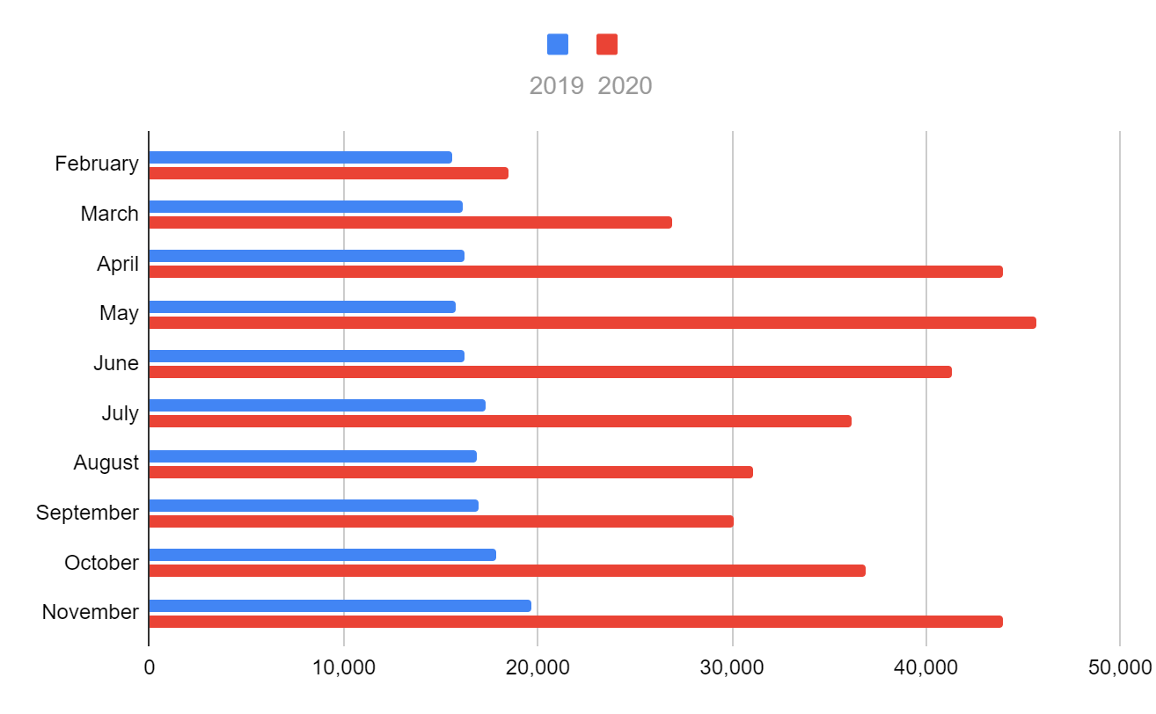

*Chart 1: Number of 3-day parcels distributed by 83 independent food banks in the UK, Feb to Nov 2019 and 2020.*

Chart 1 clearly demonstrates the increase in food distribution in 2020 versus 2019. One of the main reasons attributed to the dramatic UK-wide increase during this period is in relation to the Covid-19 pandemic.

## The impact of Covid-19 Pandemic on Food Security

Many research groups are examining the implications and impact of the Covid-19 pandemic on food security. One such charity that works in partnership with researchers, campaigners, community bodies, industry, Government, and citizens to galvanise the UK’s diverse agents of change is the Food Foundation. In their ‘A crisis within a crisis’ report, they analyse this correlation.17

According to The Food Foundation, food insecurity was already prevalent in the UK before the pandemic but was dramatically exacerbated by Covid-19, leaving many people vulnerable to hunger and poor diets. Over the period August 2020 to January 2021, 4.7 million adults (9% of all households) have experienced food insecurity. This includes 1.6 million adults who report having had to go a whole day without eating due to not being able to afford or access food. Food insecurity levels remain higher than pre-Covid-19 levels.

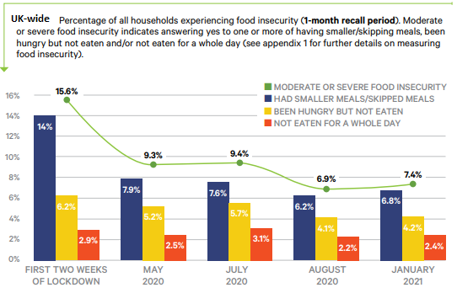

*Chart 2: Percentage of households experiencing food insecurity in the UK, 2020 - early 2021.*

This trend identified during the pandemic continues at present according to the latest findings by the Food Foundation. In their February 2022 survey on food insecurity being a major challenge to levelling up agenda, the conclusions drawn are as follows:

- New data released by the Food Foundation shows continued rise in food insecurity across the UK. Compared with July 2021 the figure has risen from 7.3% of UK households to 8.8% (4.7 million adults) in the past month.

- People who are limited a lot by disability are approximately 5 times more likely to be food insecure (in the past six months) than people who aren’t living with a disability.

- The cost-of-living crisis has meant that 62% of households have experienced higher energy bills this winter and prices are set to rise further in April (to be announced this weekend).

- People on Universal Credit are 5 times more likely to have experienced food insecurity.18

## Number of parcels distributed by food banks in Scotland, 2015 to 2022

Another key contributor in the NGO environment on food-related issues is The Trussell Trust. The research conducted by Trussell Trust is considered by numerous organisations as one of significance and reliability in terms of its data in this field and with notable activism efforts towards eradicating food poverty. The work covered by The Trussell Trust is a major contribution towards that direction as it provides the evidence basis for necessary policy changes. The Trussell Trust publishes its end-of-year (April - March) statistical analysis alongside publicly available datasets. We obtained the latest reports and statistics19 including data for April 2021 - March 2022 for further examination and creating the following visualisation graphs, focusing on their findings on Scotland along with the whole of the UK.

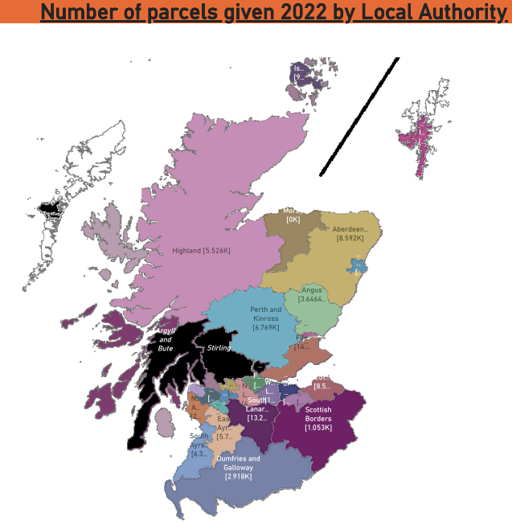

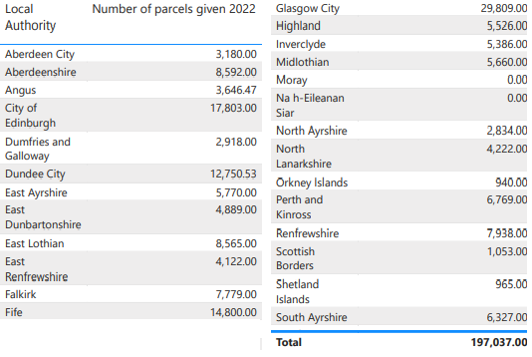

*Map & Dataset 1: Food parcels distributed in Scotland in 2022, as recorded by Trussell Trust* [*here*](https://www.trusselltrust.org/news-and-blog/latest-stats/end-year-stats/)*.*

The geographical visualisation of Maps 1 which is based on the latest Trussell Trust dataset shows that the main areas of food parcel distribution in 2022. Like in previous years according to the same statistical source the largest numbers of food parcels distributed are in the cities of Glasgow, Edinburgh, Dundee, Aberdeen and the central belt between Glasgow and Edinburgh which are the most densely populated areas in Scotland. We also examined the number of food distributions comparing the changes during recent years.

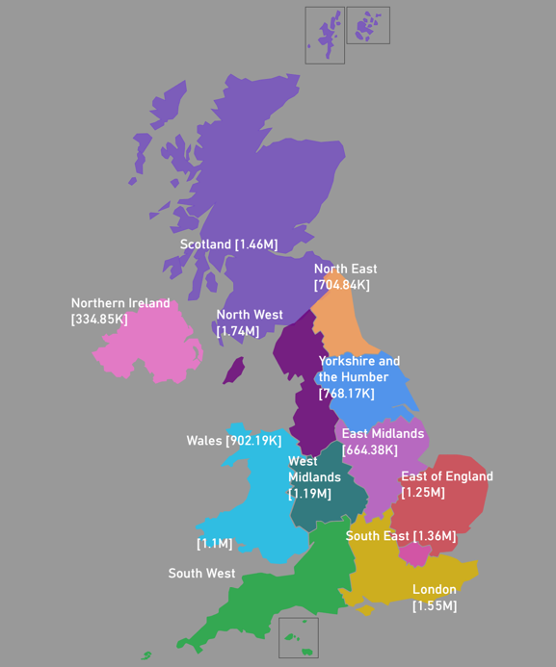

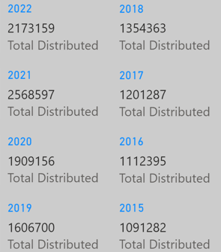

*Map & Dataset 2: Food parcels distributed in the UK during 2015 - 2022 as recorded by Trussell Trust* [*here*](https://www.trusselltrust.org/news-and-blog/latest-stats/end-year-stats/)*.*

Map 2 displays the total numbers of food parcels distributed by Trussell Trust registered food banks throughout the UK throughout the period 2015 - 2022. It is worth noting the large numbers reported for the city of London and Scotland during this period.

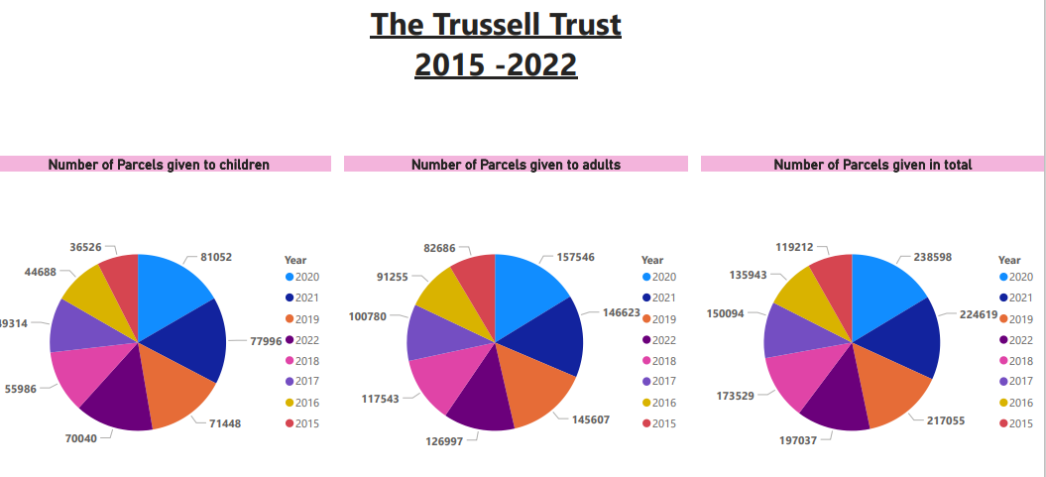

*Chart 3: Emergency food parcels distributed in Scotland as recorded by Trussell Trust, 2015 - 2022.*

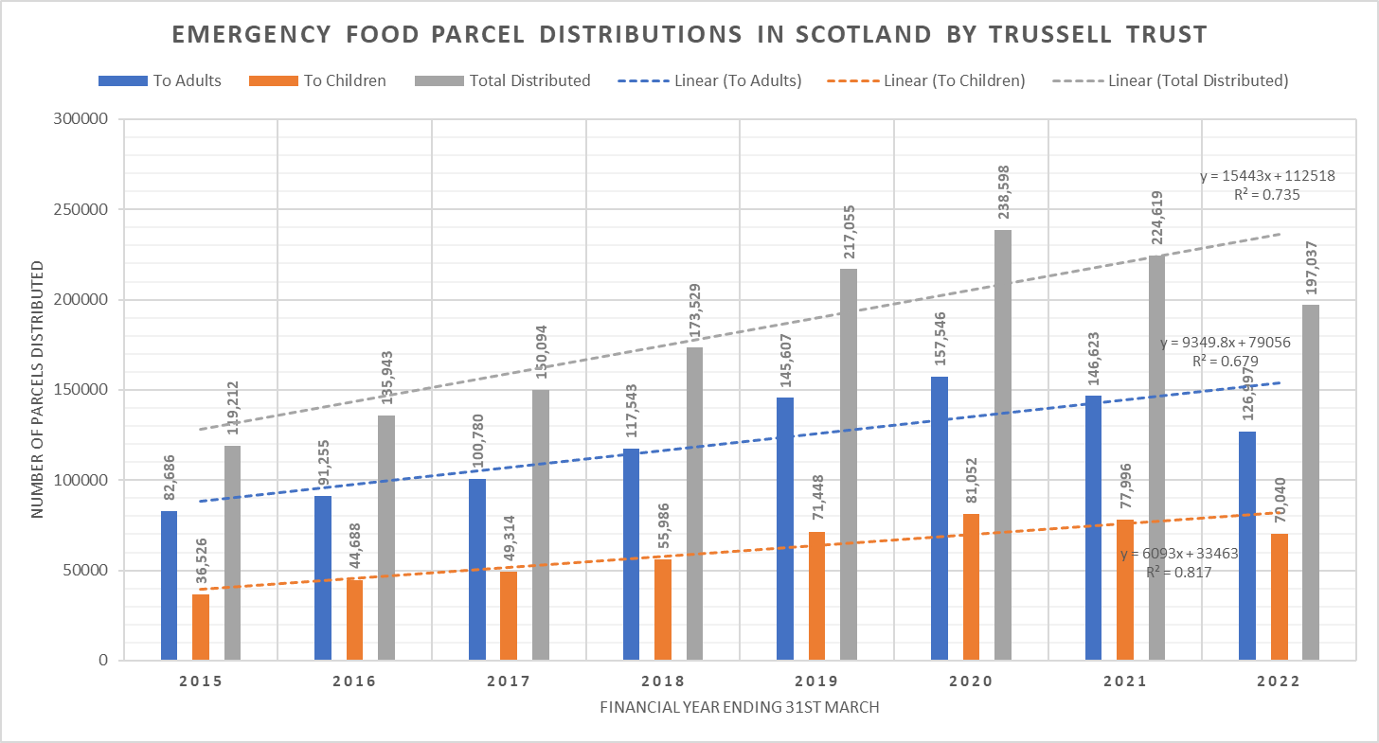*Chart 4: Emergency food parcels distributions in Scotland as recorded by Trussell Trust, 2015 - 2022.*

Charts 3, 4 & 5 are in accordance with the information provided by IFAN and The Food Foundation as they display the same upwards trend in food distribution hence the need for food support, particularly in 2020 at the start of the pandemic. It is essential to clarify that although the actual numbers of food parcels are lower in 2021 and 2022 in comparison to 2020, they are clearly still higher in comparison to earlier years like 2015, 2016, and the linear trendline in the above bar chart describes a continuous high number of food parcels distributed over this period.

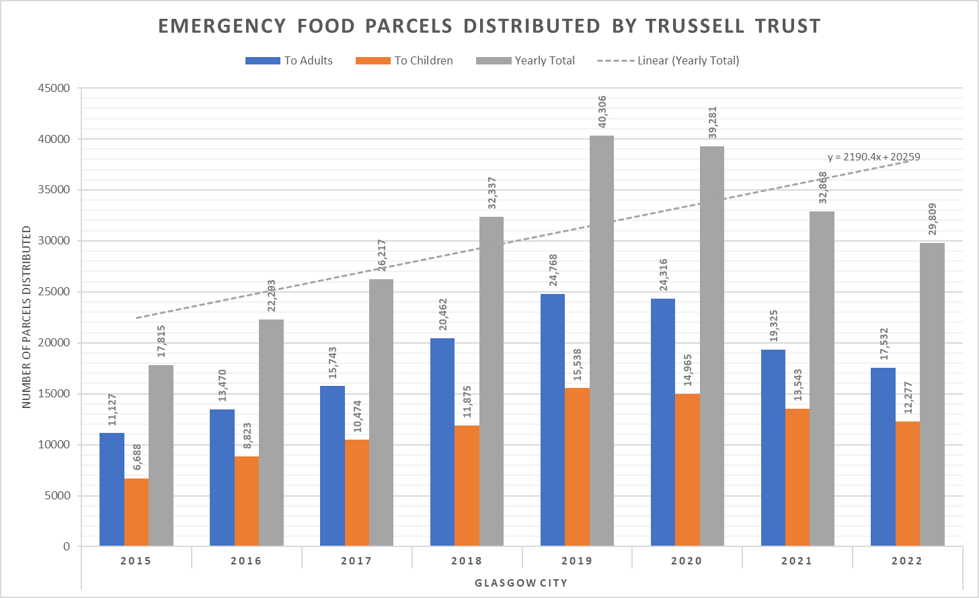*Chart 5: Emergency food parcels distributed in Glasgow as recorded by Trussell Trust, 2015 - 2022.*

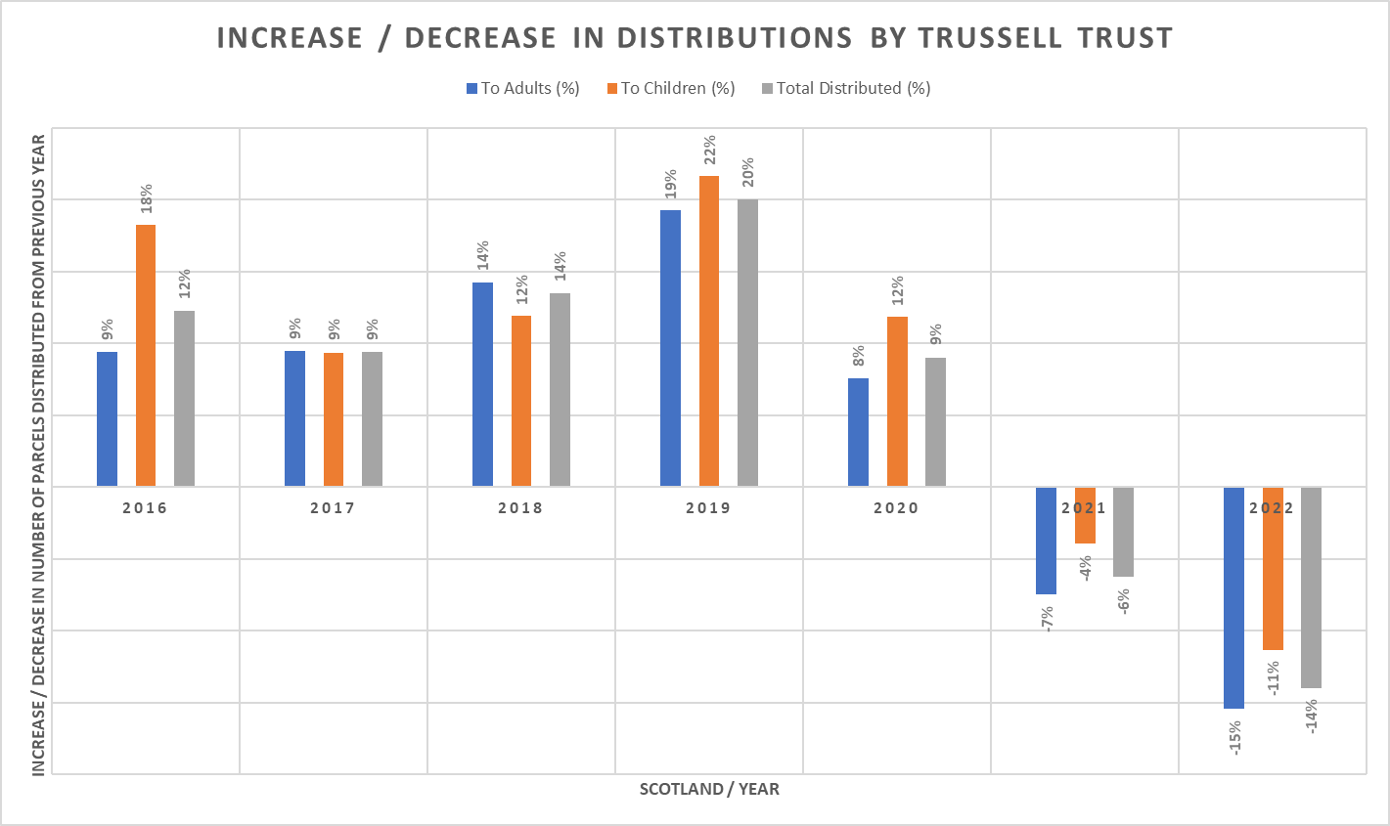

*Chart 6: Increase/Decrease percentages in distributions in Scotland as recorded by Trussell Trust, 2016 - 2022.*

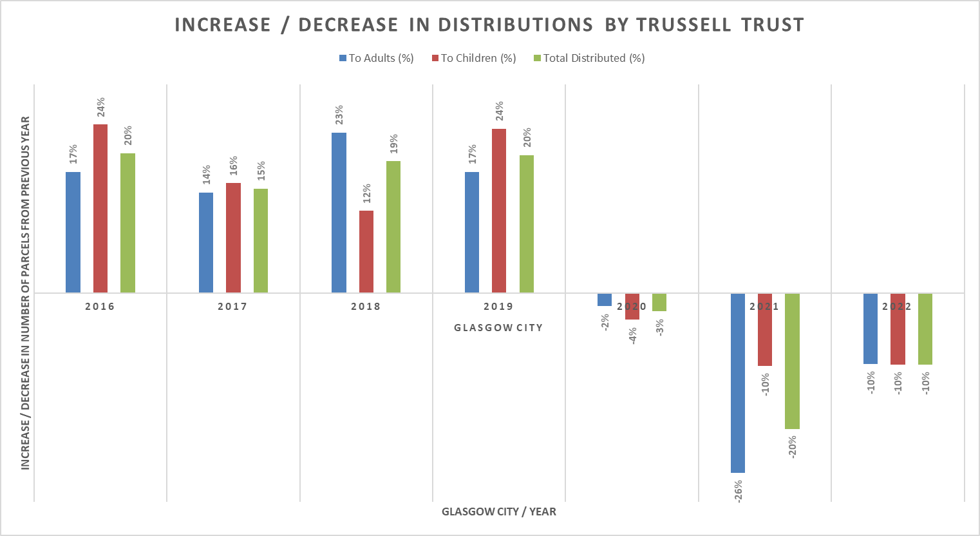

*Chart 7: Increase/Decrease percentages in distributions in Glasgow as recorded by Trussell Trust, 2016 - 2022.*

Charts 6 & 7 demonstrate the change in food distribution as percentages comparing each year to the previous. Therefore, even though there is a negative percentage for years 2021 and 2022, this does not undermine the existence of Food Poverty and the complexity in these percentage visualisations lies on the fact that 2020 was stricken by an out-of-the-ordinary massive disturbance - that of the Covid-19 pandemic - exacerbating the problem of Food Poverty even more.

The Trussell Trust charity also analyses this phenomenon on a UK-wide comparison as well by stating that the picture of need is mixed across the UK. While there has been an overall acceleration in need seen at food banks in the Trussell Trust network, this has not been the case in all areas. It is important to acknowledge that there is significant variation across local authorities, and the nations and regions of the UK in the recorded change in the number of parcels distributed in 2021/22. For example, there have been recorded decreases in the number of parcels distributed in Scotland (- 17%) and Wales (-4%) when compared to the same period in 2019/20, however, need in these areas remains concerningly high – with almost 200,000 parcels distributed last year in Scotland alone.

Lower percentage increases or decreases should not necessarily be interpreted as demonstrating lower levels of need in these areas as data from food banks in the Trussell Trust network forms only part of the picture of need. There are many factors that affect the mixed picture of need seen across the UK, including operational differences in the way food banks are run, the availability of alternative emergency food provision, policy differences and the differential sustained economic impact of the pandemic.20

Additionally, in Trussell Trust’s 2021 annual report, the national particularities are addressed by stating that data from partners and collected by the Scottish Government indicate that overall levels of need in Scotland remain high like in other parts of the UK.21

## Types of organisations that reported providing free/subsidised food in Scotland

Although the Trussell Trust is one of the largest charities distributing emergency food in Scotland, they are only part of the picture. There are many other groups and organisations also involved but whose activity to date has been largely hidden by the fact that they are independent and not part of a national network. To build a clearer picture and understanding of the organisations responding to household food insecurity across Scotland, the Scottish Government commissioned the Glasgow Charity Urban Roots in 2019 to conduct a Food Insecurity Mapping survey.22

The report was published in 202023 and it starts to shed light on the complex network of organisations that are involved in providing free or subsidised food in Scotland. It also reveals that for many of these organisations, they provide more than just food. Of the 411 organisations that reported offering additional activities and services, almost a third reported that they provided social activities and group events (31%) and around a third reported offering advice and support (30%).24

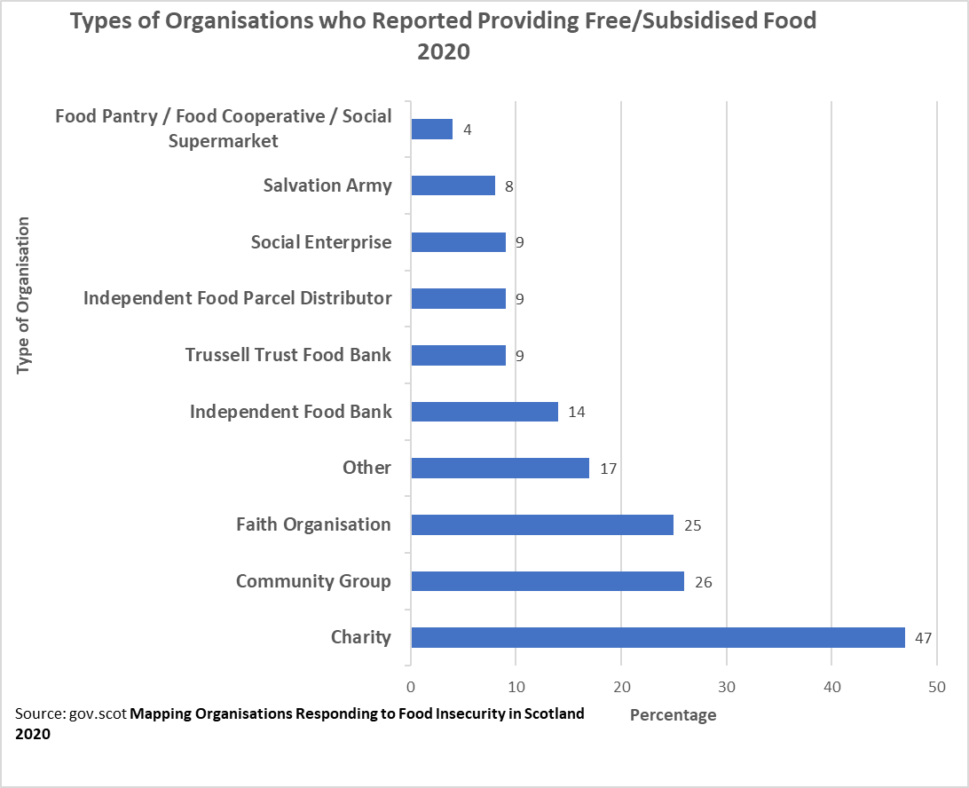

*Chart 8: Types of organisations that reported providing free/subsidised food in Scotland, 2020.*

## Measuring Food Security

Although the food bank statistics produced by charities and organisations such as the Trussell Trust, the Food Foundation and IFAN are important in shedding light on the extent of food poverty; until recently this was virtually the only data available. One of the criticisms levelled at the UK Government by campaigners has been the lack of any official nationwide measurement of food security. Indeed, there was a perceived reluctance on the part of the Government to introduce one despite countries such as the USA and Canada doing so. How, it is argued, can the Government even start addressing the problem when it has no idea of its extent?25 This hard-headedness of the Government appeared to be softening when in February 2019, Amber Rudd the then Work and Pensions secretary for the UK, admitted that the rollout of Universal Credit had contributed to an increase in food bank use. This was a watershed moment up to this point; something that had been steadfastly denied by the Government. This was followed up by the announcement of the introduction of a Food Security measurement. This has been included as a series of questions within the Family Resources Survey (FRS); a continuous household survey which collects a variety of information on the incomes and circumstances of a representative sample of private households in the UK and is the main poverty data source used by the Scottish Government26.

However, although an improvement, there are limitations to the usefulness of the current Food Security data available. Firstly, this has only been available since 2019 - 2020, so it is not possible yet to use it to detect trends or patterns until more data has been collected.

Secondly, due to the impact of the Covid-19 pandemic on data collection, the poverty and income statistics for the latest three-year period 2018 - 2021 were not considered robust enough by the Scottish Government to be published as official statistics. "*Absolute poverty is a condition where household income is below a necessary level to maintain basic living standards, while relative poverty is a condition where household income is a certain percentage below median income. The criteria of relative poverty will change by economic growth while absolute poverty does not*" 27.

And finally, the FRS only provides information at a national level and therefore cannot be used to track Food Security at a local level. One the key data summary we looked at from the above Scottish government links is the percentages of people in poverty in relation to food security (Table 2).

|  |  |  |  |  |  |
| --- | --- | --- | --- | --- | --- |
|  | **Very Low %** | **Low %** | **Marginal %** | **High %** | **Not in High Food Security %** |
|  |  |  |  |  |  |
| **All children** | 7 | 8 | 10 | 75 | 25 |
| **Children in relative poverty** | 14 | 21 | 16 | 48 | 51 |
| **Children in absolute Poverty** | 15 | 21 | 14 | 49 | 50 |
|  |  |  |  |  | 0 |
| **All People** | 4 | 4 | 7 | 84 | 15 |
| **People in relative poverty** | 12 | 13 | 14 | 60 | 39 |
| **People in absolute poverty** | 14 | 14 | 14 | 59 | 42 |

*Table 2: Levels of Food Security after housing costs in Scotland 2019 - 2020. Percentages of Food Security in Scotland 2019/2020.*

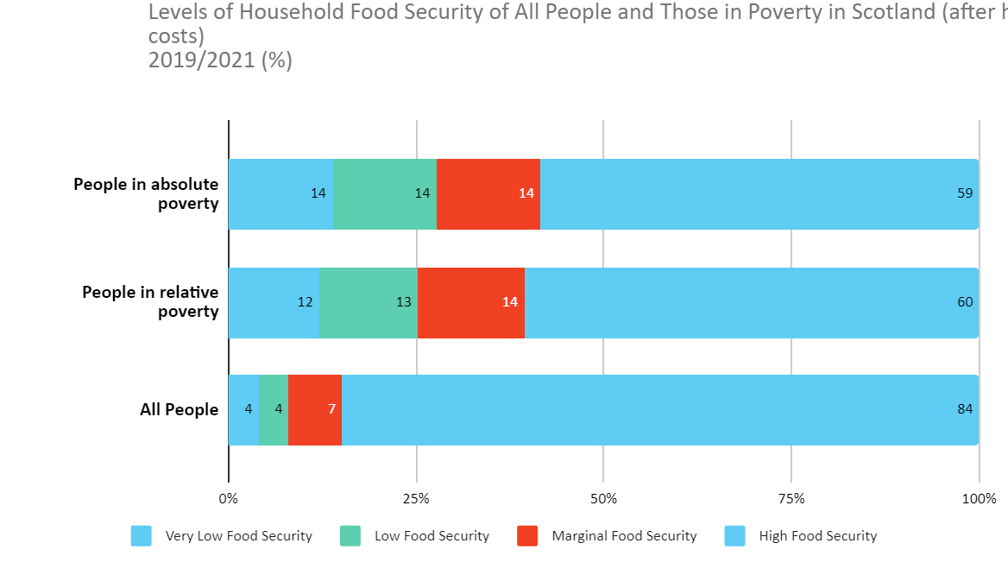

*Chart 9: Levels of Household Food Security in Scotland, 2019 - 2021.*

During 2019 - 2020, 15% of all people lived in households with marginal, low, or very low food security. This rises to 42% for those in absolute poverty and 39% for those in relative poverty. This indicates that people in poverty are more likely to live in households that lack food security, as well.

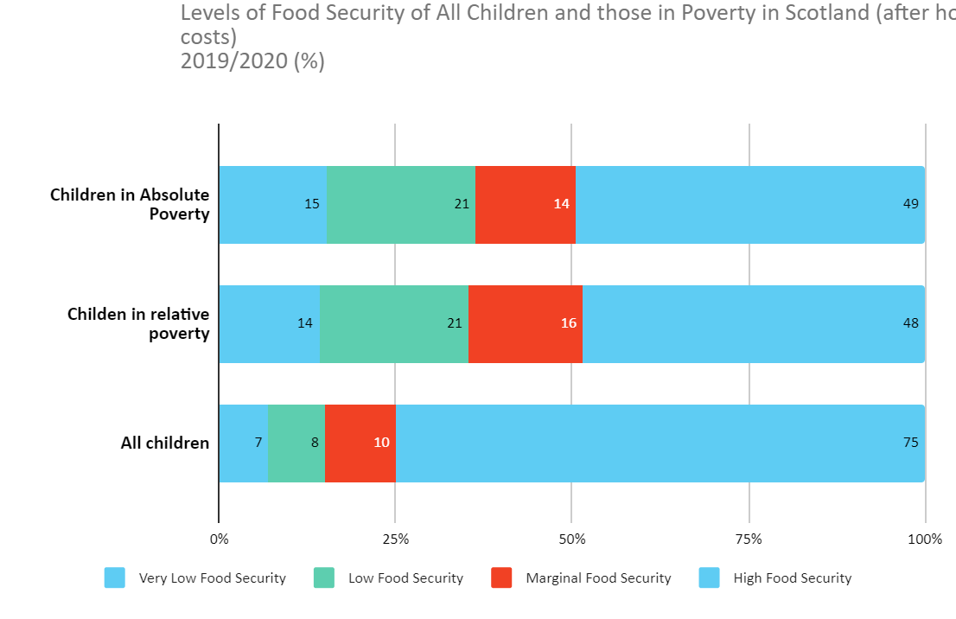

*Chart 10: Levels of Household Food Security of Children in Scotland, 2019 - 2021.*

Like the case of adults, the data analysis provides the same correlation between poverty and food security for children. In 2019 - 2020, 25% of all children lived in households with marginal, low, or very low food security. This rises to 50% for those in absolute poverty and 51% for those in relative poverty. The conclusion that can be drawn from this is that children in poverty are more likely to live in households that lack food security, as well.

Moreover, if we compare the data of children in poverty to adults in poverty as demonstrated by charts 9 and 10, we can conclude that children in poverty are affected by higher levels of food insecurity which is a major disadvantage for the overall population.

## Food Poverty and Income

Another aspect that is considered a factor for increases in Food Poverty and needs to be taken into consideration in terms of data analysis is income levels and the stagnation of individuals’ earnings.

Chart 10 illustrates how the UK wage growth has generally lagged the cost of living over the last decade. This divergence is most marked from around March 2021 onwards when the sustained, steep rise in the cost of food, energy and household goods pushed inflation to a 30-year high28. The consequence of this is increased pressure on household budgets, with the greatest impact being felt by those with low incomes. There is growing concern that some households are having to make tough choices between food and heating29.

*Chart 11: Percentage change in real average UK weekly earnings vs CPIH, Feb 2010 - Feb 2022.*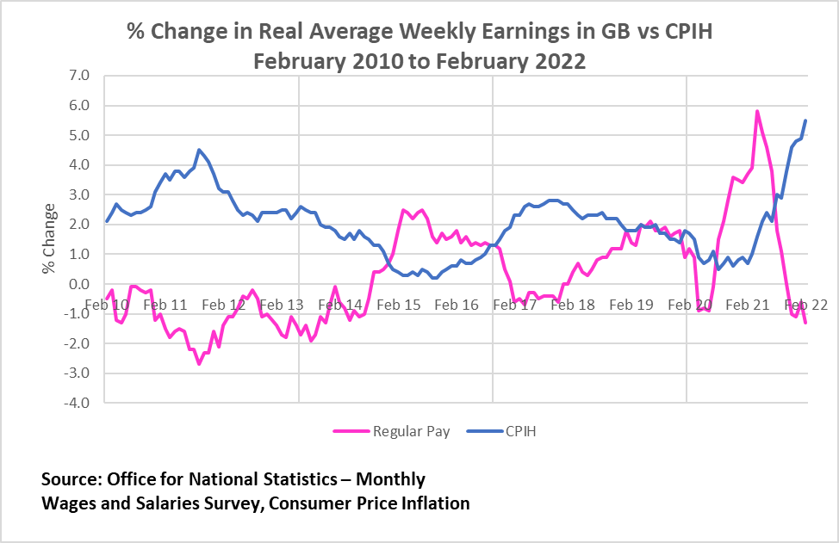

*\*CPIH (Consumer Prices Index incl. owner occupiers' housing costs).*

## Food Poverty and Cost of Living

When this stagnating average income level is accompanied by the increase in the cost of living, one of the subsequent effects is the rise in Food Poverty. In the report’s section about the Jack Monroe case study, we saw in detail the importance of how the increase in the cost of goods and services affects the dynamics in food security, as well.

Chart 12 below demonstrates that low-income households spend a higher percentage of their budget on food, housing, and energy. Poorest households spend nearly 40% in contrast to the richest who spend just under 20%.3

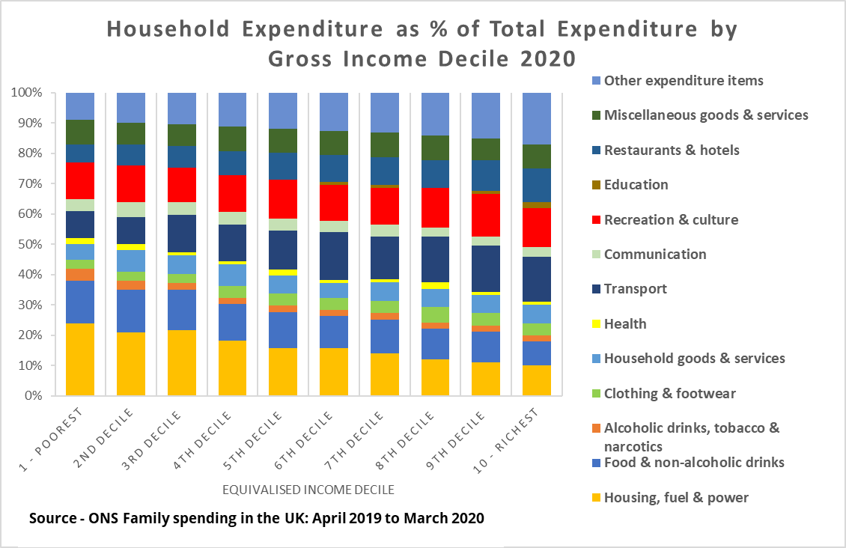

*Chart 12: House Expenditure as % of Total Expenditure by Gross Income Decile, UK 2020.*

The following 2 graphs chart the change in the CPI (Consumer Prices Index) retail food price indices from the start of the Covid-19 pandemic through to March 2022. Although the general trend is upwards, looking at the overall change in the first chart we can see a very rapid increase from September 2021 onwards.

In the second chart, looking at the effect of the CPI on different food categories, all groups can be seen to increase but milk, cheese and eggs are affected the most (almost 9% increase since the start of the pandemic).31

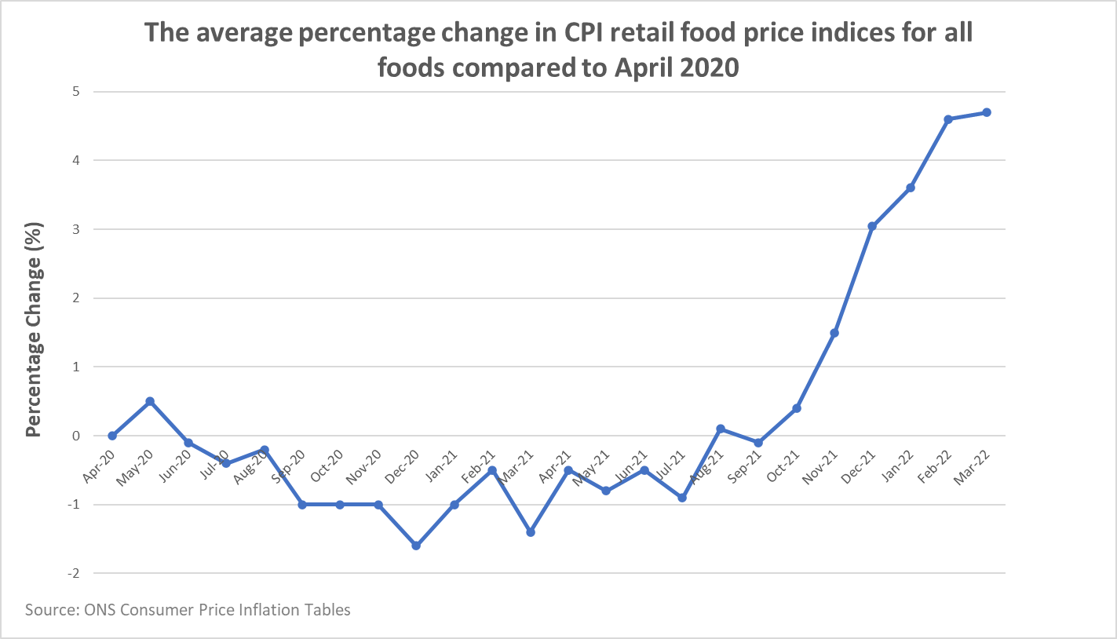

*Chart 13: UK average percentage change in CPI retail food price indices for all foods, Apr 2020 - Mar 2022. *CPI (Consumer Prices Index).*

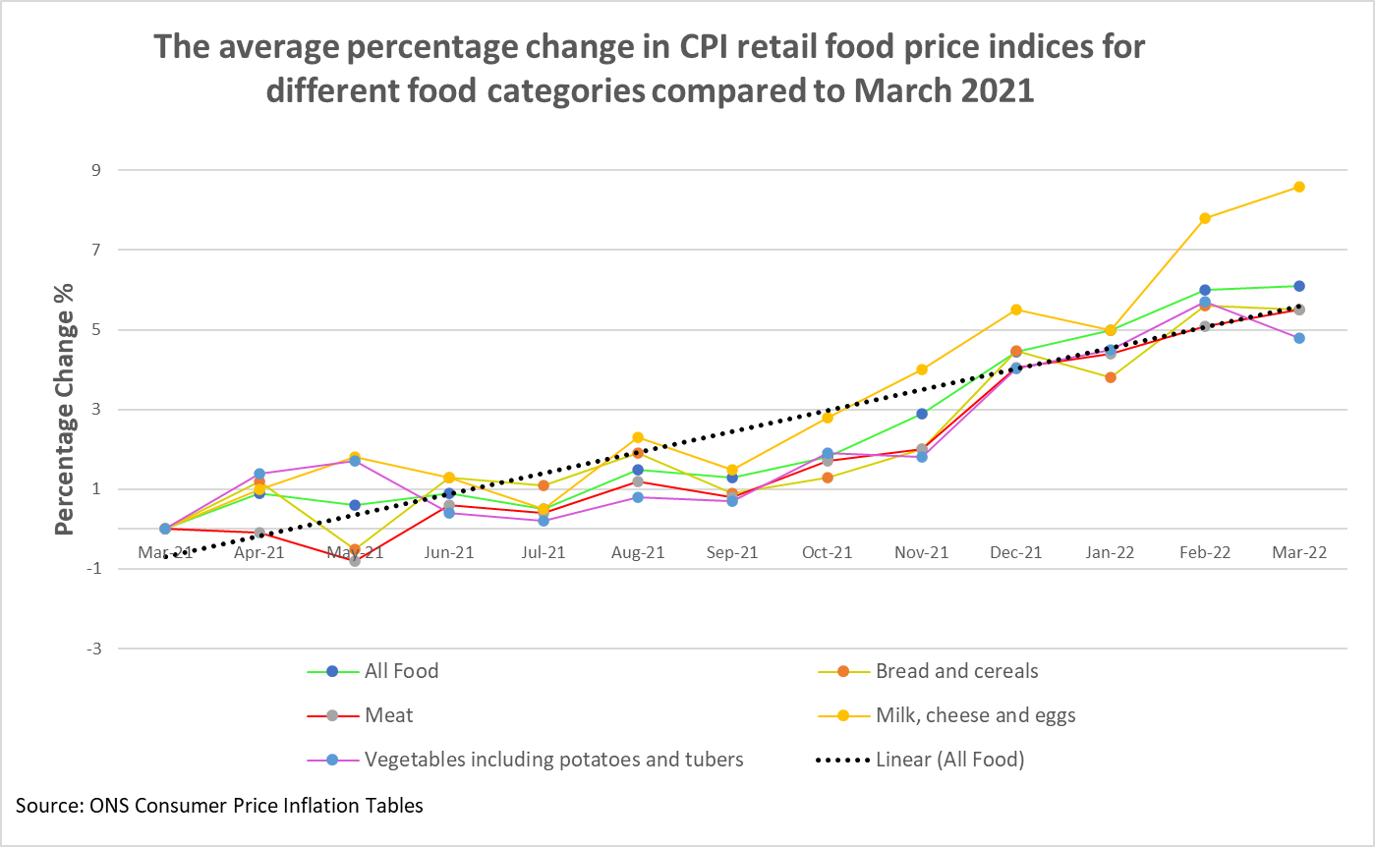

*Chart 14: UK average percentage change in CPI retail food price indices for all foods, Mar 2021 - Mar 2022. *CPI (Consumer Prices Index).*

The Opinions and Lifestyle Survey (OPN), which collects data from individuals (aged 16 years or older) in Great Britain on a fortnightly basis, was adapted from March 2020 to become a weekly survey used to collect data on the impact of the coronavirus pandemic on day-to-day life in Great Britain.  It moved back to a fortnightly data collection from 25 August 2021 onwards.

The OPN currently covers topics relating to health, including how the coronavirus (COVID-19) pandemic is affecting households and individuals in Great Britain; it also covers a range of other topics such as experiences regarding cost of living and shortages of goods. These are the most recent UK-wide stats (April 2022) on the impact of Cost of Living for individuals during the Covid-19 period.32

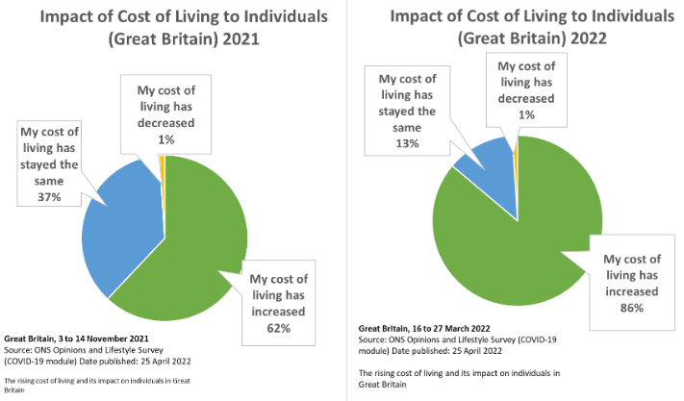

*Chart 15: Impact of Cost of Living to Individuals in Great Britain 2021 - 2022.*

In 2021, 61% of individuals reported an increase in their cost of living. This has risen to 86% in 2022.

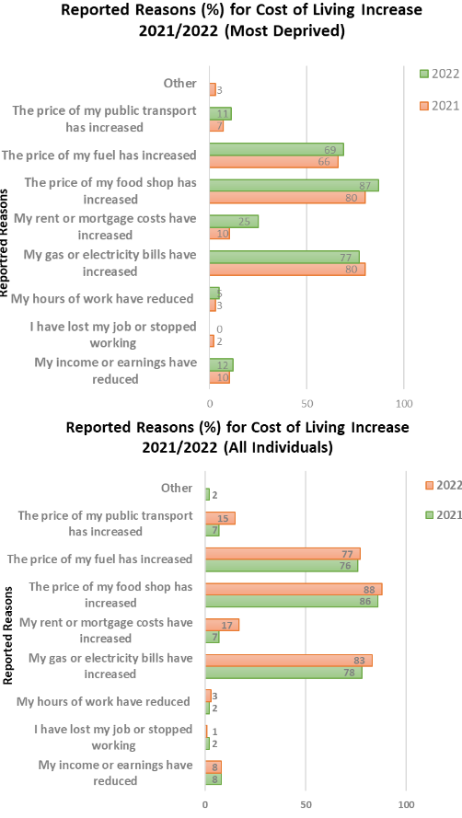



*Chart 16: Reported Reasons for the Cost-of-Living Increase in the UK, 2021 - 2022.*

In 2021 and 2022, the most common reason given for an increase in an individual's cost of living was "*The price of my food shop has increased*".

# 

# Conclusions

The main conclusion of our report is that there is a confirmed rise in Food Poverty as recorded by Third Sector groups and governmental departments and demonstrated in the data analysis report section.

What we can infer from all the data examined and figures is that a) reliance on food banks may be a far bigger problem than is realised. b) The difficulties of getting an accurate picture of food banks use precisely because many of them are independent (i.e., non-Trussell Trust) and thus "off the radar". c) The governments are only just starting to track food poverty through official figures (i.e., the Food Security indicator that is now included as part of the FRS (Family Resources Survey since 2019). However, although an improvement on what we had before this indicator is also questionable as it only tracks food security at a national level and thus cannot give an accurate picture of what is happening at the local level.

We also need to address the effects and consequences of food poverty - especially on both the emotional and physical development of children which in turn affects the well-being levels and progress for every country. Research has indicated that a child growing up in poverty who has experienced one or more periods of food insecurity is more likely to have health problems than children who haven't.33 Putting aside any arguments as to the morality of a first-world country allowing food poverty to exist, there is the stark reality that there is an associated financial cost addressing the ongoing increased health care needs of such individuals.

Another aspect of the Food Poverty crisis is its long-term health implications deriving from the quality of cheaper mainly processed food in contrast to a varied diet that includes fresh produce and supports a strong immune system and satisfactory health levels. According to a detailed and well-researched article by the Guardian on this front, “*Covid has brought to the surface some hard truths about the British food system, and what a poor job it does of feeding the whole population. As the first lockdown hit in March 2020, plenty of better-off British households were able to carry on eating much as before, while millions more were plunged into food poverty. According to data from the Food Foundation**34**, during the first two weeks of lockdown in the spring of 2020, the proportion of households facing food insecurity doubled to more than 15%. Black and Asian people have been twice as likely to suffer hunger during the pandemic as their white counterparts. As Marcus Rashford said in a letter to parliament about food poverty in June 2020, “This is a system failure”. But it is a system failure that existed for decades before the pandemic at long last pushed it onto the national agenda.*”35

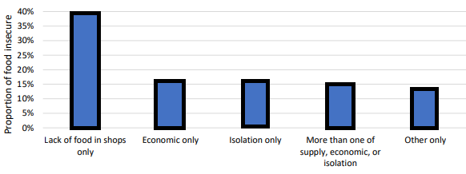

*Chart 17: Proportion of adults experiencing food insecurity for various reasons since the start of the pandemic in the UK, 2020.*

Factors that are associated with a higher risk of economic food insecurity in the UK are in most cases also associated with risk of any type of food insecurity and more specifically economic food insecurity. The most vulnerable groups include the following:

• People with serious health conditions and disabilities

• People with children

• Unemployed people

• Black, Asian, and Minority Ethnic groups.36

According to recent findings by The Food Foundation37 on dietary inequalities, the poorer UK households would have to spend approximately 40% of their income for healthy food. As a result, framing healthy eating as a matter of choice which is practised by some media outlets and individuals that have not been affected by poverty increases is dishonest and unethical. It's not a choice if you can't afford healthy food. In depth research on this matter shows that obesity is determined to a large extent by environmental factors such as socioeconomic inequality, the rise of processed food and the way that cities are designed and built to facilitate car use but not enough green spaces and agricultural areas in proximity. Unfortunately, the argument that weight and consumption of ultra-processed food is all about personal responsibility and lifestyle choices: just eat less and exercise more is also adopted by some policy makers whereas more wide support should be provided for securing the eradication of Food Poverty.

# 

# Recommendations

Eradicating food insecurity must be a priority for Government, policy makers, public and private organisations, and communities to ensure the long-term satisfactory health levels of all people. This is not a political statement – it is a moral imperative and a necessity for the well-being and progress of a nation – no one should go hungry in a developed country today. Our key recommendations are not intended to be an exact recovery package but important starting points on the road to improving diets and food security on a long-term basis.

An important aspect that has come up while examining the issue of Food Poverty is that there is a plethora of parallel situations that aggravate this crisis ranging from income stagnation, inflation affecting products that become unaffordable for a rising section of the population, cultural trends (i.e., heavily promoted processed foods on mass media channels in contrast to minimal advertisements for healthy food options) and so on. In effect, the Government through policy making that aims to tackle Food Poverty must address this multitude of problems and reasons behind Food Poverty and provide solutions that not only rely on the gap filled by the capacity the food banks might have on an NGO level of action.

There is also a general lack of recording and statistical data availability on a local level, in particular for cities and districts in comparison to the UK-wide data on issues like pricing, income levels, food deliveries by charities etc. That means that a lot of relevant information, case stories (i.e., of people that might have needed support with food supplies for the first time in their life and received it through friends and acquaintances rather than a food bank so in a way they go unregistered but still being heavily affected by the problem) and actions taking place on a community unrecorded level might slip under the radar. This results in an unequal balance for how measurements are being done and addressing inequalities in general.

For this reason, policy making needs to address the issue of Food Poverty having a potentially much higher quantitative extent and food poverty recording needs to be improved by higher public spending on this via local NGOs and charities. Charities need more help; they don't have time to deal with the high demands. For example, as Alan Crossan, the Founder of Clutha Trust has shared with us, his charity is trying very hard to provide help that is required in the local Glasgow community and there is an increase in the demand for support in recent years. The work of charities like The Clutha Trust needs to be financially supported further by the Government so that more detailed recording and solutions are provided on the local level.

A deeper collaboration between the Government, specialised organisations like health and education departments, businesses, and the Third Sector should be the norm for a better coverage of this crisis and bringing necessary policy changes into practice.

Another aspect that needs to be included in the updating of governing rules is the environmental issues with the need for sustainability as a driving force. As Nourish Scotland have advocated, simultaneously climate change threatens the ability of food systems to deliver good food for all. The need and urgency to safeguard food systems, from food production to delivering, consumption to waste, is undeniably a key element to tackling climate change and improving planetary and human health.37

Better education on healthy diets should also be adopted, minimising bad eating habits i.e., via a tax on ultra-sugary products and making fresh healthy food like vegetables, iron/vitamin-D fortified products more affordable.

On a community level this cultural shift can be advanced by ensuring the presence of affordable and accessible sports facilities and activity centres where people can easily exercise and receive advice towards a better diet. This should be complemented by the provision of free mental health support avenues for people struggling with problems caused by health or poor diet issues.

Every year The Food Foundation publishes 'The Broken Plate’, an informative flagship report demonstrating the state of the current food system and the enormous challenges faced by individuals and communities in ensuring that everyone in the UK can afford and access a healthy and sustainable diet. The report identifies different relevant areas on the issue, outlining the general state on this front as well as recommendations for every main area addressing metrics of the data research on Food Poverty.38

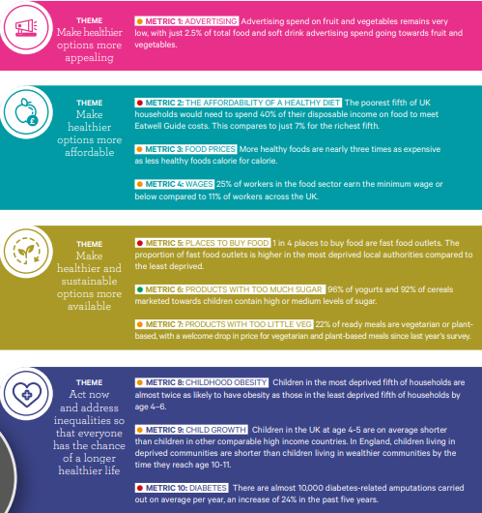

*Chart 18: The Broken Plate report, The State of the Nation's Food System, UK 2021.*

As a group, in terms of our recommendations upon examining the various socio-economic aspects and data available on Food Poverty, we do agree with the above calls for action associated with every metric The Food Foundation organisation has identified. As an extension to further this study, more data collection could enhance the overview of this issue and further comparisons of regions within Scotland, as well as on a UK level.

# Acknowledgments

We thank Frank Duffy, Robert Henderson, Paul McCreery, Grace McNair, Stefan Meyer, Gabriele Janusonyte, Brian Murphy, Flavio Garinei, Karen Scott, Lila Rose, and the whole of the Code Division group for their kind support throughout the course and this teamwork project. We would particularly like to thank our mentor Jayanthi Santhanam for providing excellent support and guidance throughout the completion of this report. We thank Mr Alan Crossan, Founder of Clutha Trust and Dr Maike Waldmann of the Scottish Government Equality and Social Justice Analysis Department for their valuable contributions to our project by sharing information on the topic and engaging with our team's research work. We would also like to thank individuals like Jack Monroe, as well as groups and organisations that are doing tremendous and inspirational work towards alleviating food poverty like IFAN, The Food Foundation, The Trussell Trust and all Third Sector groups that deserve recognition for their hard work.

# References

1. <https://www.who.int/news/item/13-07-2020-as-more-go-hungry-and-malnutrition-persists-achieving-zero-hunger-by-2030-in-doubt-un-report-warns>

2. <https://www.fao.org/3/cb4474en/online/cb4474en.html#chapter-3_0>

3. <https://www.concern.org.uk/news/explained-sustainable-development-goals>

4. <https://data.gov.scot/poverty/2021/persistent.html>

5. <http://www.healthscotland.scot/health-inequalities/fundamental-causes/poverty/food-poverty#:~:text=Food%20poverty%20is%20commonly%20defined,be%20able%20to%20do%20so>'

6. <https://www.trusselltrust.org/news-and-blog/press-and-media/press-releases/>

7. <https://www.trusselltrust.org/wp-content/uploads/sites/2/2015/06/PRESS-RELEASE-Emergency-Food-for-Benefit-Reassessment-clients.pdf> , <https://www.trusselltrust.org/wp-content/uploads/sites/2/2015/06/Social-Fund-Reform-and-Trussell-Trust-Foodbanks-1.pdf> , <https://www.trusselltrust.org/wp-content/uploads/sites/2/2015/06/FOODBANK-CHARITY-DISTURBED-BY-DOWNING-STREETS-COMMENTS-ON-HUNGER.pdf> , <https://www.trusselltrust.org/wp-content/uploads/sites/2/2015/06/Increasing-numbers-turning-to-foodbanks-since-Aprils-welfare-reforms-1.pdf> , <https://www.trusselltrust.org/wp-content/uploads/sites/2/2015/06/Low-income-and-welfare-problems-lead-to-40-percent-rise-in-foodbank-use.pdf> , <https://www.trusselltrust.org/wp-content/uploads/sites/2/2015/06/Foodbank-use-remains-at-record-high.pdf>

8. <https://cookingonabootstrap.com/2022/04/12/its-not-about-the-pasta-kevin-jack-monroe/>

9. <https://www.theguardian.com/society/2022/jan/22/were-pricing-the-poor-out-of-food-in-the-uk-thats-why-im-launching-my-own-price-index> <https://www.thestar.co.uk/business/consumer/who-is-jack-monroe-what-is-the-vimes-boots-poverty-index-and-what-has-the-terry-pratchett-estate-said-3544234>

10. <https://www.cluthatrust.org/> <https://www.facebook.com/Cluthatrust>

11. <https://www.trusselltrust.org/hunger-free-future/join-us/>

12. <https://foodfoundation.org.uk/>

13. <https://www.foodaidnetwork.org.uk/>

14. <https://data.gov.scot/poverty/2021/#food-security-2>

15. <https://www.ons.gov.uk/>

16. <https://uploads.strikinglycdn.com/files/f94e04eb-00ff-4ab1-99ae-6a901ee885b4/IFAN%20REPORT%2022.12.20%20FINAL.pdf?id=3360657>

17. <https://foodfoundation.org.uk/sites/default/files/2021-10/FF_Impact-of-Covid_FINAL.pdf>

18. <https://www.foodfoundation.org.uk/press-release/new-data-shows-food-insecurity-major-challenge-levelling-agenda>

19. <https://www.trusselltrust.org/news-and-blog/latest-stats/end-year-stats/>

20. <https://www.trusselltrust.org/wp-content/uploads/sites/2/2022/04/EOY-Stats-2022-Data-Briefing.pdf>

21. <https://www.trusselltrust.org/wp-content/uploads/sites/2/2021/04/Trusell-Trust-End-of-Year-stats-data-briefing_2020_21.pdf>

22. <https://www.urbanroots.org.uk/food-mapping-research/>

23. <https://www.gov.scot/publications/mapping-organisations-responding-food-insecurity-scotland/pages/1/>

24. <https://www.gov.scot/publications/mapping-organisations-responding-food-insecurity-scotland/pages/5/>

25. <https://www.google.com/url?q=https://www.theguardian.com/society/2016/apr/20/people-going-hungry-government-food-insecurity&sa=D&source=docs&ust=1652123172454137&usg=AOvVaw0BFJY_6wrF7M69-u7UW7-Q>

26. Source: <https://data.gov.scot/poverty/2021/#Local_poverty_analysis>

27. Source: <https://www.gov.scot/collections/poverty-and-income-inequality-statistics/#lateststatistics>

<https://www.economicshelp.org/blog/glossary/definition-of-absolute-and-relative-poverty/>

[28. https://www.ons.gov.uk/peoplepopulationandcommunity/personalandhouseholdfinances/incomeandwealth/bulletins/householddisposableincomeandinequality/financialyearending2021](https://www.ons.gov.uk/peoplepopulationandcommunity/personalandhouseholdfinances/incomeandwealth/bulletins/householddisposableincomeandinequality/financialyearending2021)

29. <https://www.theguardian.com/business/2022/mar/30/soaring-uk-prices-force-some-to-choose-between-heating-and-eating>

30. <https://www.ons.gov.uk/peoplepopulationandcommunity/personalandhouseholdfinances/expenditure/bulletins/familyspendingintheuk/april2019tomarch2020>

31. <https://www.ons.gov.uk/economy/inflationandpriceindices/datasets/consumerpriceinflation>

32. <https://www.ons.gov.uk/peoplepopulationandcommunity/personalandhouseholdfinances/expenditure/articles/therisingcostoflivinganditsimpactonindividualsingreatbritain/november2021tomarch2022>

33. Kirkpatrick, Sharon & McIntyre, Lynn & Potestio, Melissa. (2010). Child Hunger and Long-Term Adverse Consequences for Health. Archives of paediatrics & adolescent medicine. 164. 754-62. 10.1001/archpediatrics.2010.117.

34. <https://foodfoundation.org.uk/publication/vulnerability-food-insecurity-covid-19-lockdown>

35. <https://www.theguardian.com/food/2021/nov/30/break-junk-food-cycle-britain-national-food-strategy>

36. <https://foodfoundation.org.uk/sites/default/files/2021-10/Report_COVID19FoodInsecurity-final.pdf>

37. <https://foodfoundation.org.uk/initiatives/dietary-inequalities>

37. <https://www.nourishscotland.org/campaigns/climate-change-food/>

38. <https://foodfoundation.org.uk/publication/broken-plate-2021>